UNIVERSITY OF CALCUTTA

**B.Sc. (HONOURS), CBCS SEMESTER VI**

**2022**

**MULTIMEDIA AND ITS APPLICATIONS**

**(PRACTICAL)**

**C.U. Roll No. -: 193016-21-0029**

**C.U. Registration No. -: 016-1112-0281-19**

**Paper -: DSE-A-4-P**

**Subject Code -: CMSA**

**Semester -: VI**

# TABLE OF CONTENTS

|  |  |  |  |
| --- | --- | --- | --- |
| **Serial No.** | **Contents** | **Date** | **Signature** |
| **1** | Create a passport size image and arrange the multiple copy of the same image on the A4 size page. | 05/04/2022 |  |
| **2** | Change the color of the particular portion of the image using Hue saturation. | 05/04/2022 |  |
| **3** | Using pen tool remove the background of the image and put the image on a new background. | 05/04/2022 |  |
| **4** | Using Magic Eraser tool and Magic Wand tool remove the same color background of the image. | 05/04/2022 |  |
| **5** | Using clipping mask technique masking a particular portion of the image. | 05/04/2022 |  |
| **6** | Using layer mask technique masking a particular portion of the image. | 12/04/2022 |  |
| **7** | Convert a color image to Black and white. | 12/04/2022 |  |
| **8** | Reduce the noise from an audio file. | 12/04/2022 |  |
| **9** | Create a “Happy new year” GIF by using adobe Photoshop. | 19/05/2022 |  |
| **10** | Capture a video from your mobile phone and import it to your video editing software | 19/05/2022 |  |
| **11** | Create a 2-minute video about your college. | 26/05/2022 |  |
| **12** | Create a visiting card design. | 26/05/2022 |  |

# ASSIGNMENT - 1

* **Name of the Assignment:**

Create a passport size image and arrange the multiple copy of the same image on the A4 size page.

* **Procedure:**
  1. Open Adobe Photoshop.
  2. Go to File, click on open (Ctrl + O) and choose the photo.
  3. Click on the crop tool and change the preset settings by clicking on the drop-down box on the top left corner.
  4. Click on Size and resolution. Change the dimensions to width: 3.5 cm, height: 4.5 cm and resolution: 100 pixels/centimeter
  5. Now adjust the photo as per the crop frame and press Enter.
  6. Now open a new A4 page.
  7. Click on the move tool or simply press v on the keyboard.
  8. Click on the picture; drag it to the new page and leave.
  9. Now adjust the alignment manually.
  10. To give a black border all around the picture, go to edit, then stroke, change the width to 6px, the color to black and click on ok.
  11. Duplicate the image by pressing the Alt button in the keyboard to create multiple copies.
* **Input:**



* **Output:**

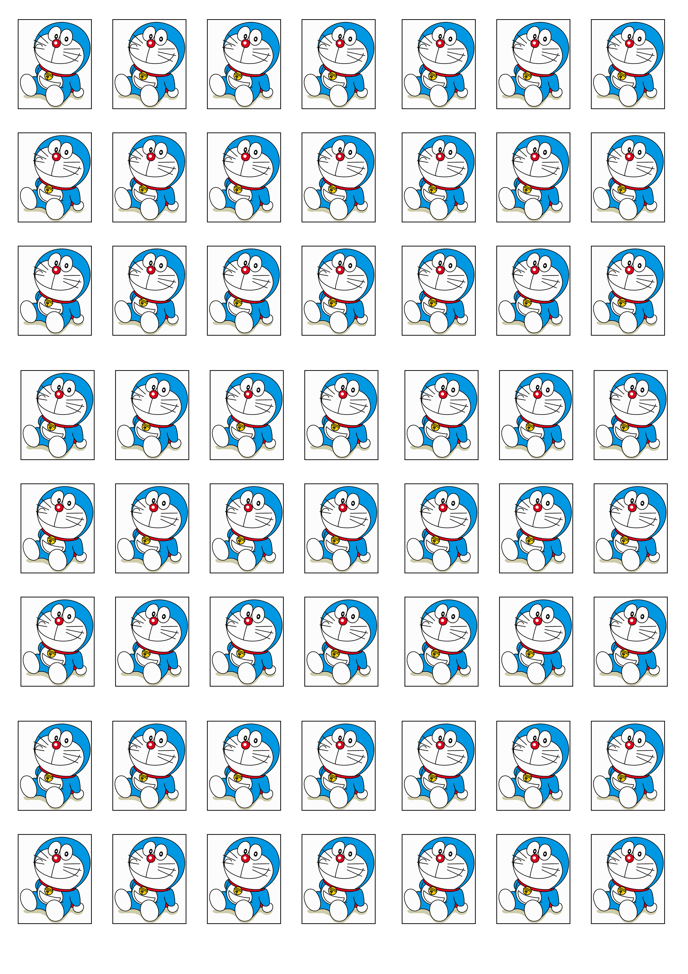

# ASSIGNMENT - 2

* **Name of the Assignment:**

Change the color of the particular portion of the image using Hue saturation.

* **Procedure:**

1. Open Adobe Photoshop.
2. Go to File, click on Open (Ctrl + O), choose the picture and open it.
3. Go to Select, click on All (Ctrl + A), then go to Edit and copy it (Ctrl + C).
4. Go to File, click on New (Ctrl + N), press OK using any name.
5. Go to Edit and paste that copied image here (Ctrl + V)
6. Click on the Polygonal Lasso tool and select the particular portion of the image where you want to change the color.
7. For selecting purpose, you can use Lasso tool, Magnetic Lasso tool or Magic Wand tool.
8. After selecting the particular portion, you’ve to go Image 🡪 Adjustments 🡪Hue/Saturation... (Ctrl+U).
9. After opening Hue/Saturation box you’ve to go Edit and click on Master (Ctrl + ~), then use the Hue slider to adjust the hue and use the Saturation slider to adjust the saturation number. Then click OK.
10. If you want to save the image after hue saturation effect, then goes to file, click on save and save the image with your preferred name

* **Input:**



* **Output:**



# ASSIGNMENT - 3

* **Name of the Assignment:**

Using pen tool remove the background of the image and put the image on a new background.

* **Procedure:**
  1. Open Adobe Photoshop.
  2. Go to File, click on Open (Ctrl + O), choose the picture and open it.
  3. Click on the Pen tool and select the background of the image
  4. Delete the background of the image.
  5. Then paste a new background in another layer.
  6. Then move the layer behind the layer which contained the subject.
  7. If you want to save the image after changing the background then goes to file, click on save and save the image with your preferred name.
* **Input:**



* **Output:**



# ASSIGNMENT - 4

* **Name of the Assignment:**

Using Magic Eraser tool and Magic Wand tool remove the same color background of the image.

* **Procedure:**
  1. Open Adobe Photoshop.
  2. Go to File, click on Open (Ctrl + O), choose the picture and open it.
  3. Using the Magic Wand, select the background and press the Delete key.
  4. Use the Magic Eraser to remove big sections of background with similar colors. Use the Background Eraser to manually remove the background.
  5. If you want to save the image then goes to file, click on save and save the image with your preferred name.
* **Input:**



* **Using Magic wand tool**

**Output:**



* **Using Magic eraser tool**

**Output:**



# ASSIGNMENT - 5

* **Name of the Assignment:**

Using clipping mask technique masking a particular portion of the image.

* **Procedure:**
  1. Open Adobe Photoshop.
  2. Create a new file with 7inches*5 inches by size.
  3. Type Wildlife and add desired blending option to text.
  4. Go to File, open the image, click on copy (Ctrl + c), and paste it in Photoshop.
  5. Then place photo in above text layer.
  6. Then apply the clipping mask on picture layer.
  7. If you want to save the image then goes to file, click on save and save the image with your preferred name.
* **Input:**



* **Output:**



# ASSIGNMENT - 6

* **Name of the Assignment:**

Using layer mask technique masking a particular portion of the image.

* **Procedure:**

1. Open Adobe Photoshop.
2. Create a new file with 7inches*5 inches by size.
3. Go to File, open the image, click on copy (Ctrl + c), and paste it in Photoshop.
4. To create a mask on the entire layer, click the Add Layer Mask button in the Layers panel, or choose Layer 🡪 Layer Mask.
5. Press ctrl+I to inverse the layer color to black.
6. Then by selecting the area you want to reveal fill it with white color or if the layer color is white then use black to hide the particular portion you want to hide.
7. If you want to save the image then goes to file, click on save and save the image with your preferred name.

* **Input:**



* **Output:**

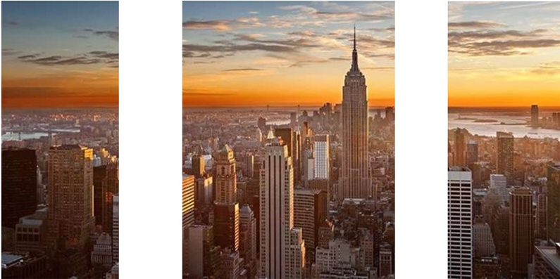

# ASSIGNMENT - 7

* **Name of the Assignment:**

Convert a color image to Black and white.

* **Procedure:**

1. Open Adobe Photoshop.
2. Go to File, click on Open (Ctrl + O), choose the picture and open it.
3. Select the entire image using ctrl+a.
4. Then go to Image 🡪 Adjustments 🡪 Black & White or by press ctrl+alt+shift+b.
5. If you want to save the image then goes to file, click on save and save the image with your preferred name.

* **Input:**

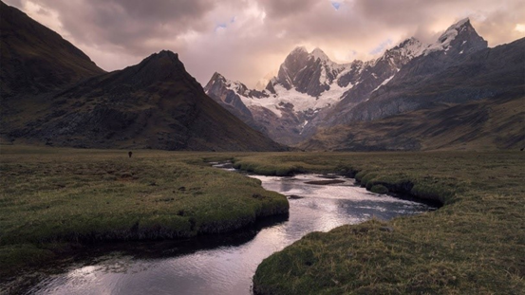

* **Output:**

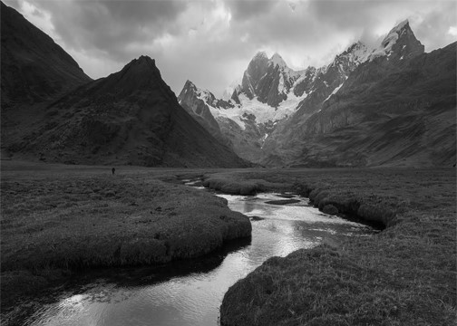

# ASSIGNMENT - 8

* **Name of the Assignment:**

Reduce the noise from an audio file.

* **Procedure:**
  1. Open Audacity.
  2. Press Record Button & record the audio.
  3. Select some portion of the audio.
  4. Go to Effect 🡪 Noise Reduction 🡪 Get Noise.
  5. Select the whole Audio Track and again go to Effect 🡪 Noise Reduction 🡪 Ok.
  6. Save the Audio file and Export the file as mp3 or wav format.
* **Input:**

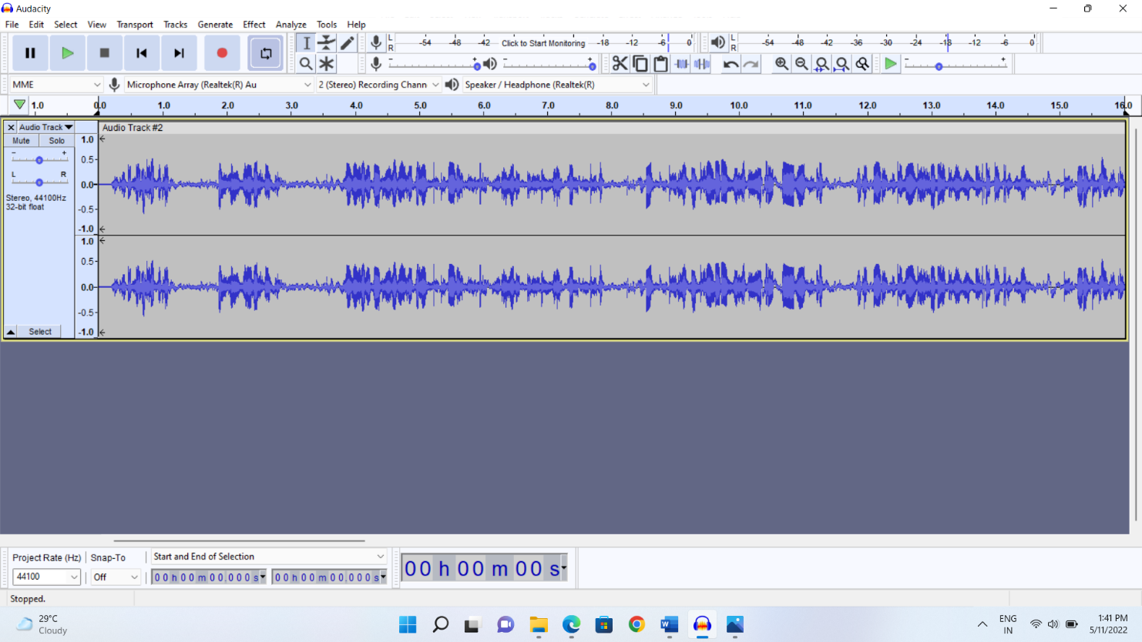

* **Output:**

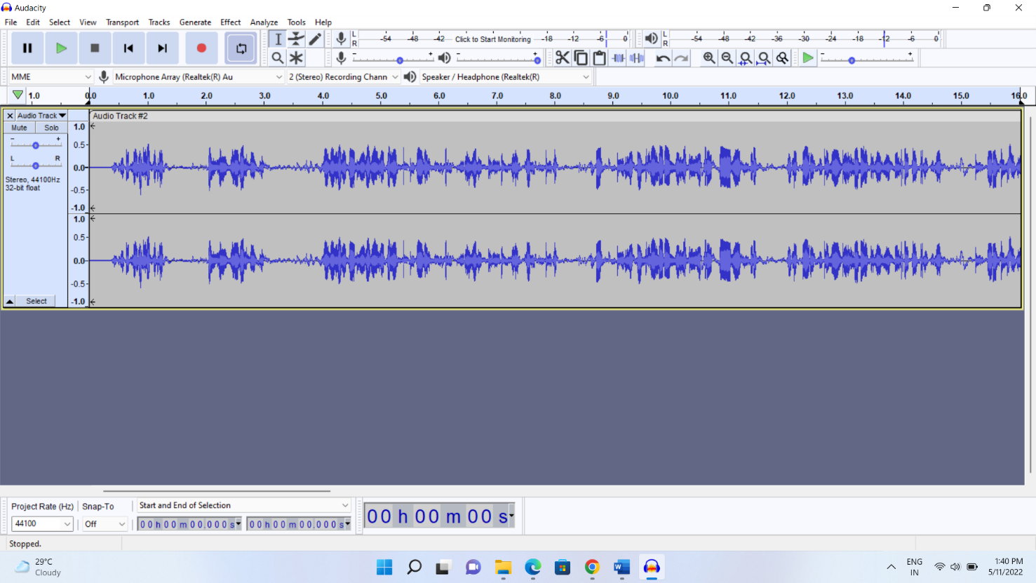

# ASSIGNMENT - 9

* **Name of the Assignment:**

Create a “Happy new year” GIF by using adobe Photoshop.

* **Procedure:**
  1. Open Adobe Photoshop.
  2. Go to File, click on Open (Ctrl + O), choose the picture and open it.
  3. Create a duplicate layer.
  4. Press CTRL+U and change the value of huge saturation.
  5. Follow the above two step 5 to 6 time(Step c and step d).
  6. Click Window 🡪 Timeline.
  7. Reduce the time of every element to 0.03s.
  8. Take all the video file into one timeline.
  9. Save the file as .gif format.
* **Input:**



**Output:**



# ASSIGNMENT - 10

* **Name of the Assignment:**

Capture a video from your mobile phone and import it to your video editing software.

* **Procedure:**

1. Capture a video from your mobile phone.
2. Click on the camera icon on your mobile phone. Camera will open.
3. Go to video option and press the red button. Start recording will show and recording will start.
4. Now press the same red button the video will stop recording and automatically saved to your storage.
5. Transfer The saved video file to your PC via data cable or any other sharing method.
6. Open your video editing Software. I am using Wondershare Filmore you can use any other software.
7. Now Select the import button. A dropdown menu will open, As shown in the figure below
8. From the dropdown menu select “import media files” a dialog box will open where you must select the file you have recorded with your mobile phone.
9. The selected file will be imported in your software.
10. Click on the imported video and you will be able to edit the video.

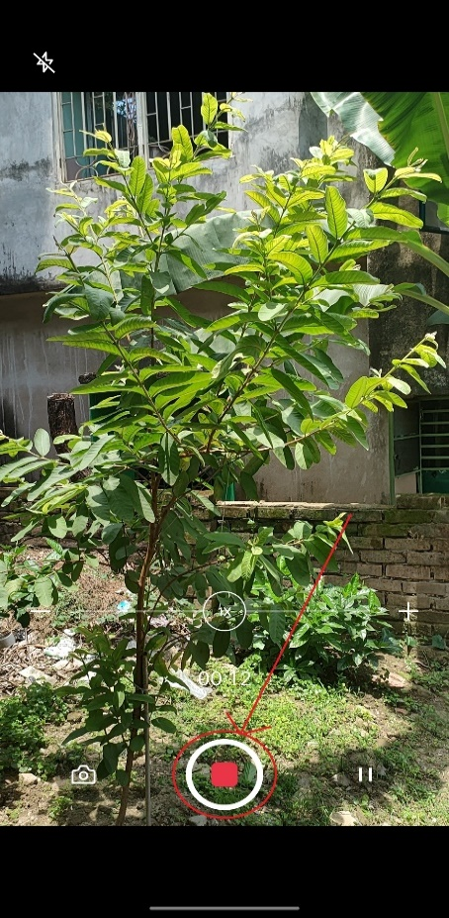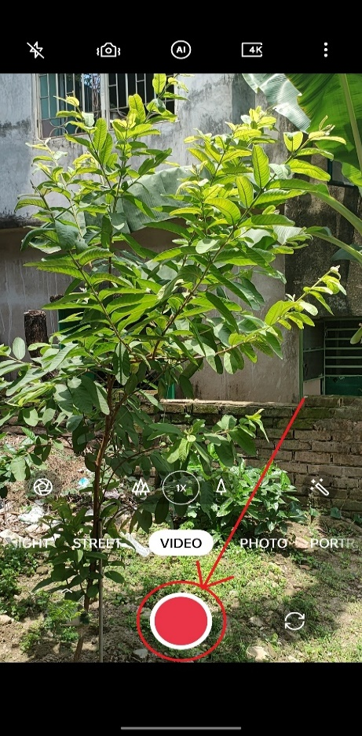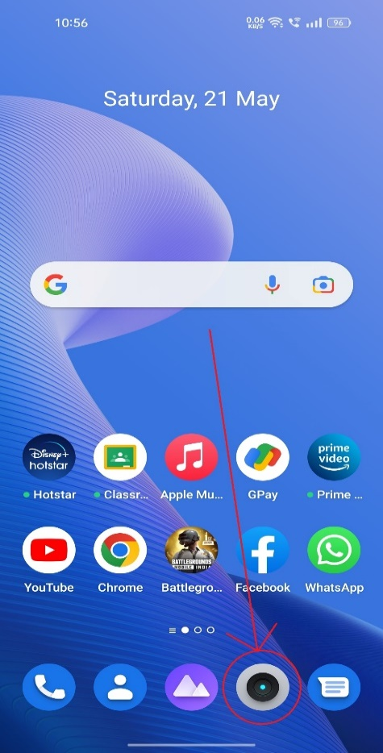**Input:**

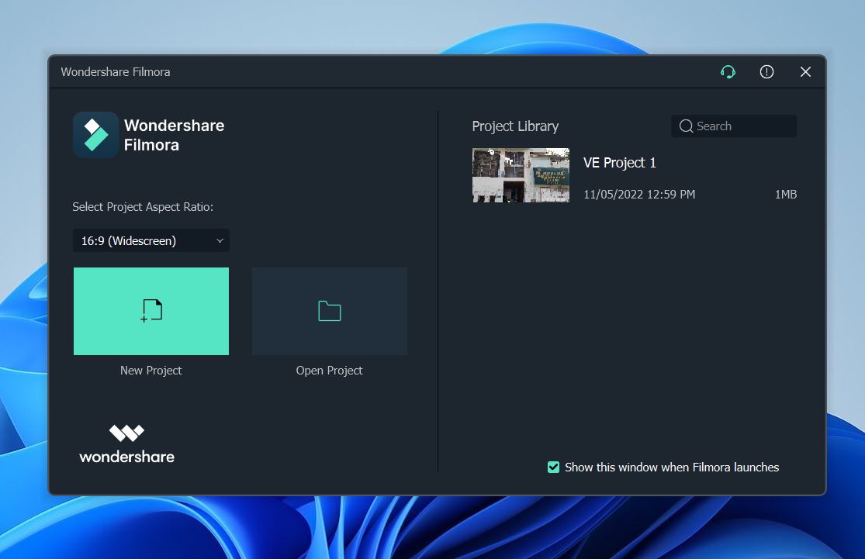

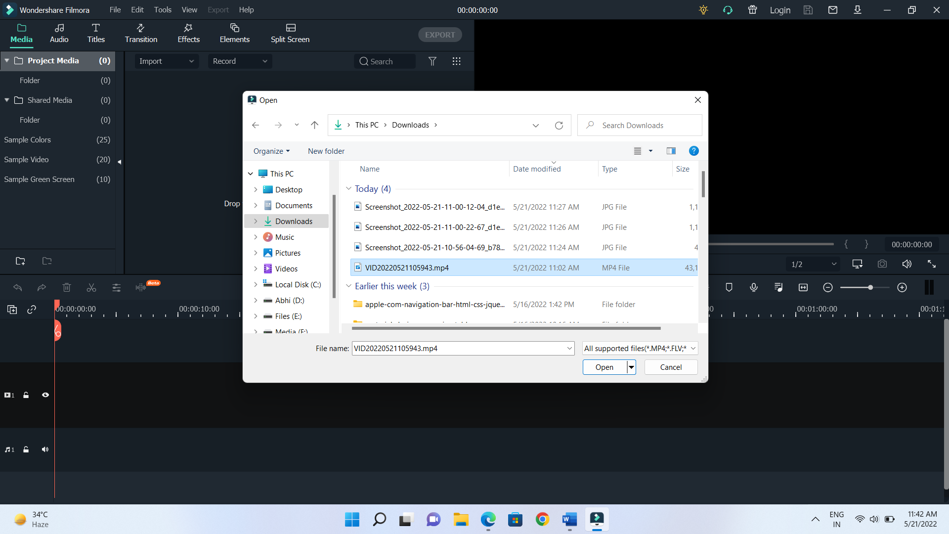

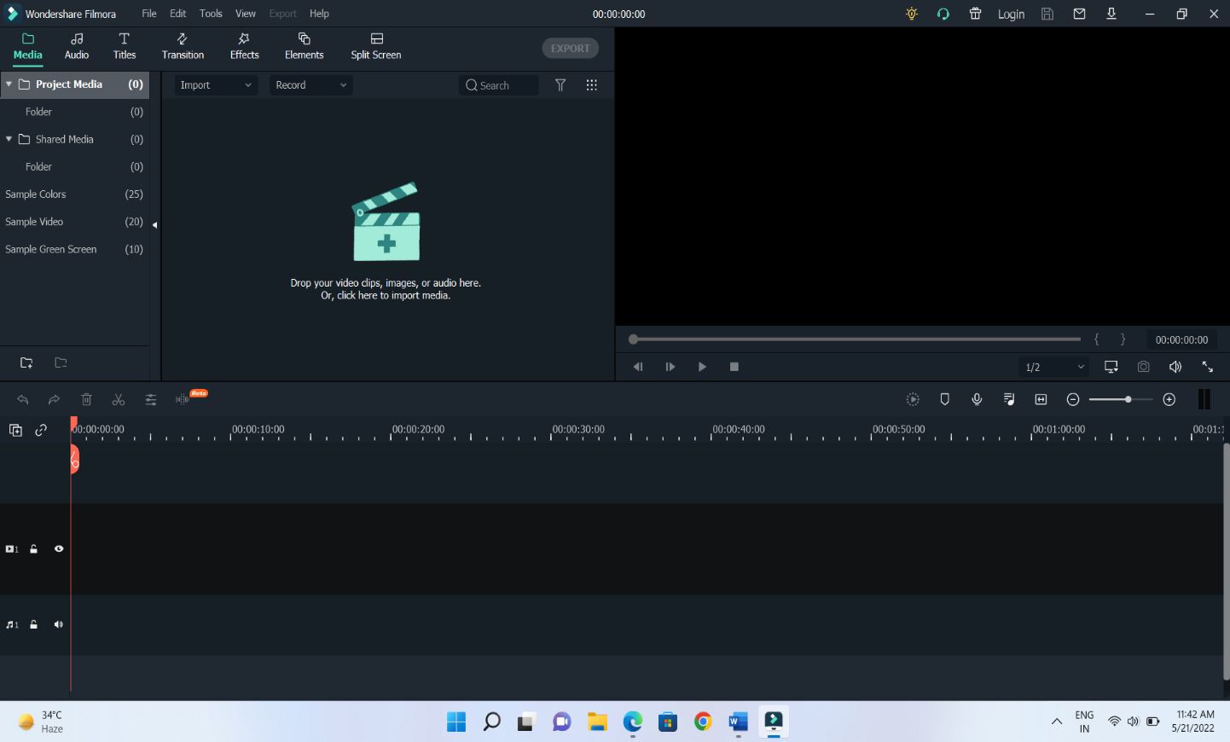

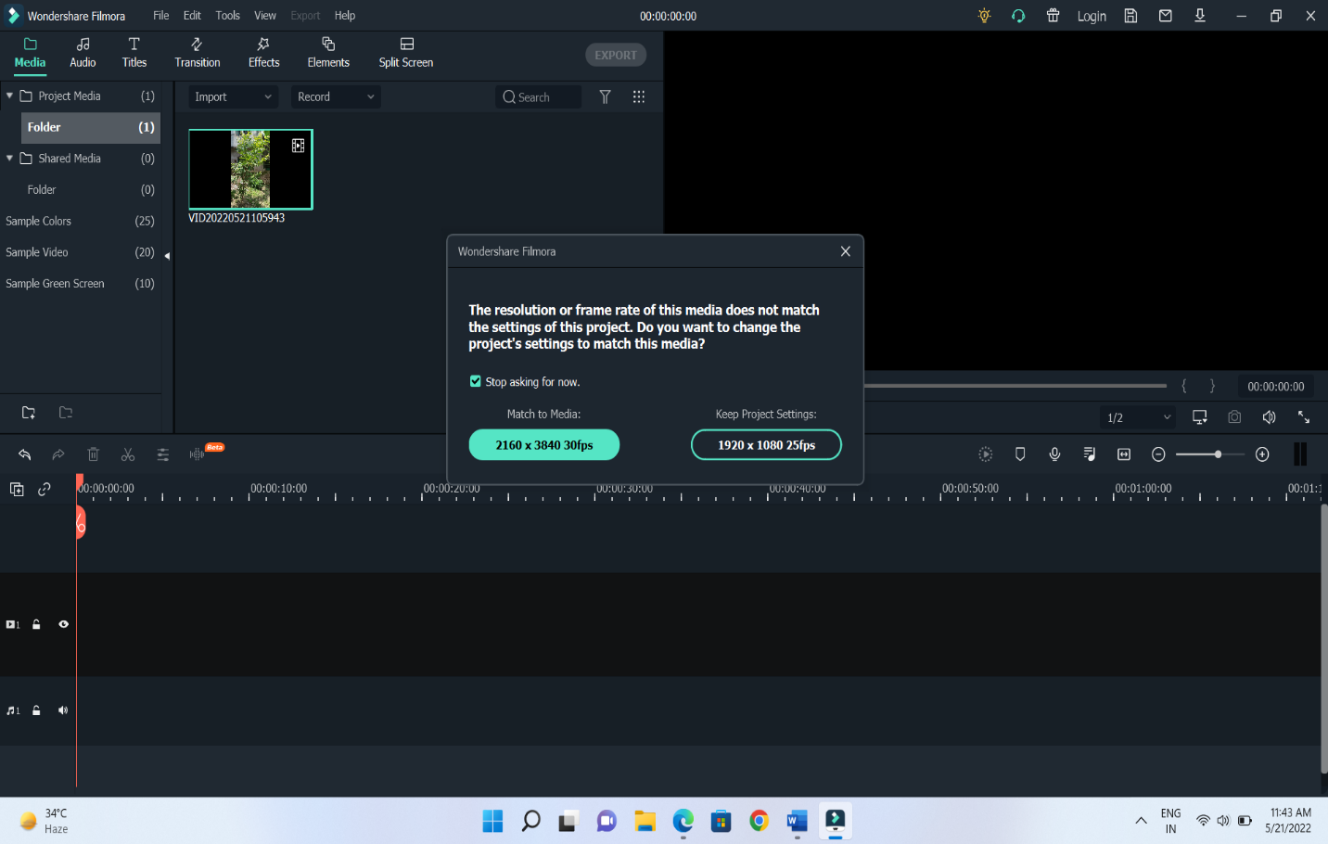

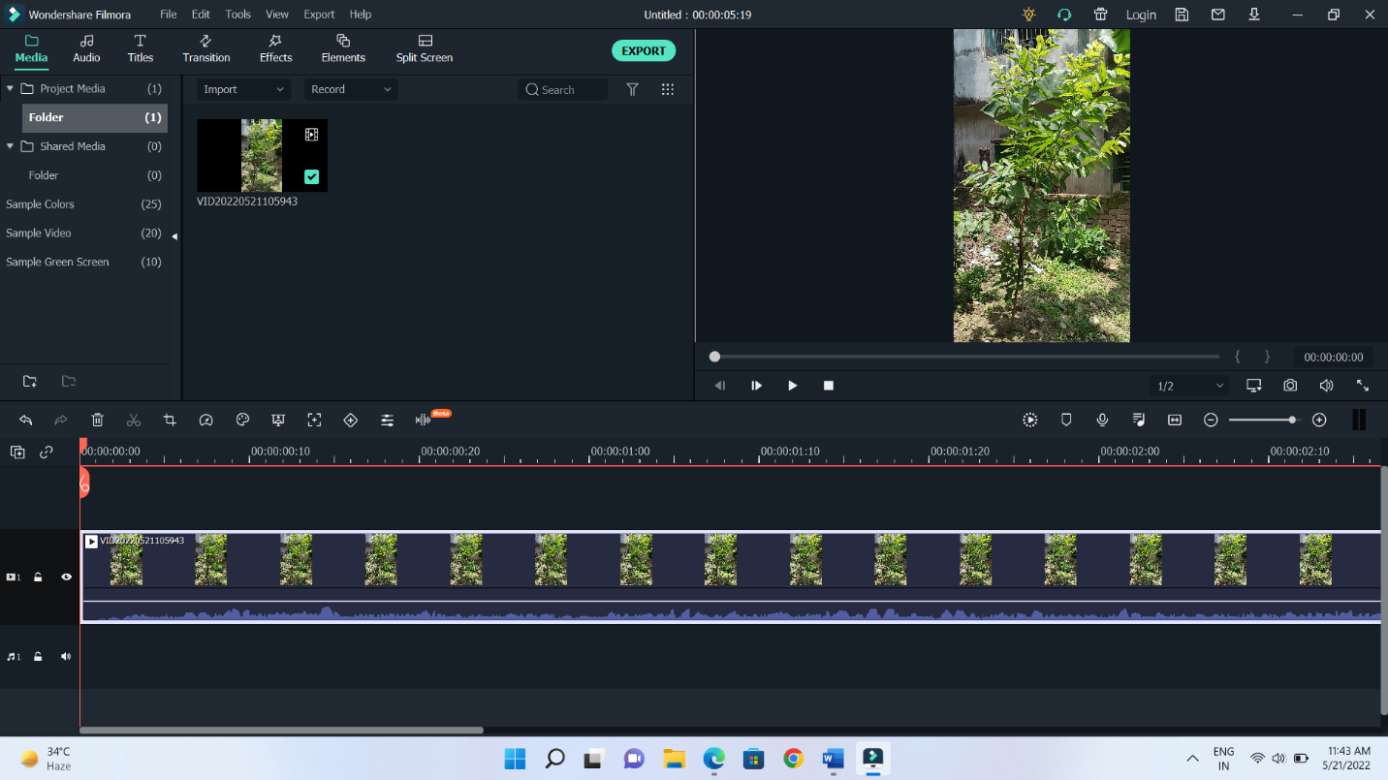**Output:**

# ASSIGNMENT - 11

* **Name of the Assignment:**

Create a 2-minute video about your college.

* **Procedure:**
  1. Open Wondershare Filmora.
  2. Select import button.
  3. Select all the media files.
  4. Drag the video file into 1st timeline.
  5. Remove unnecessary part of the video using cut tool.
  6. Drag the audio file into audio timeline.
  7. Adding transition between two video files.
  8. Save and Export the File.

**Input:**

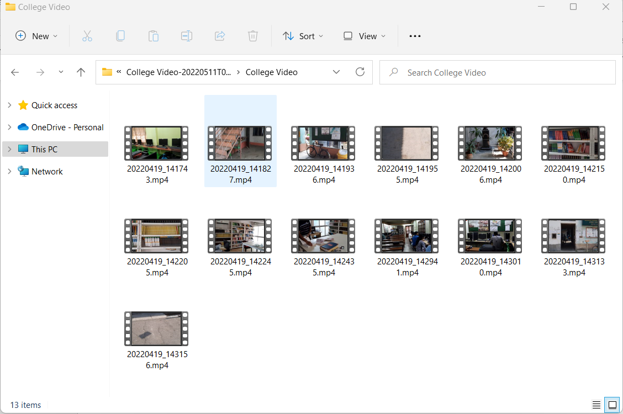

**Output:**

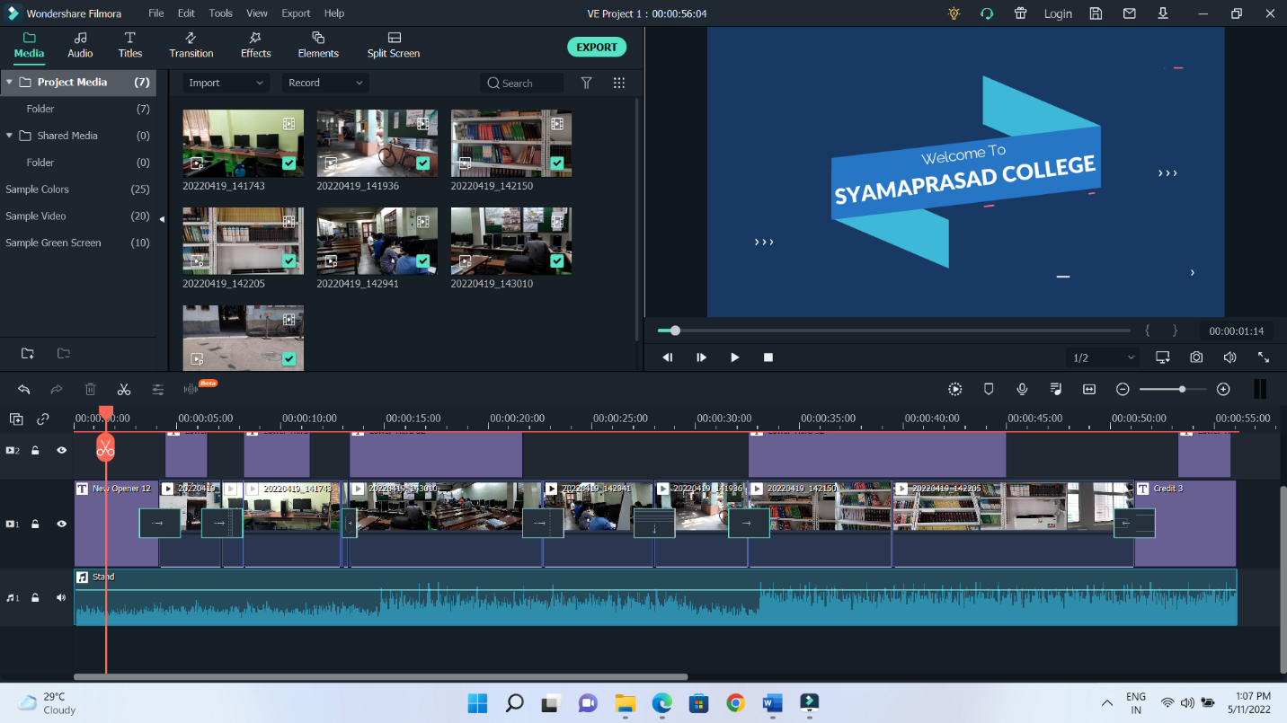

# ASSIGNMENT - 12

* **Name of the Assignment:**

Create a visiting card design.

* **Procedure:**
  1. Open Canva select marketing then select Business Card option.
  2. Select a template.
  3. Click on Upload button then select upload media then upload the image from download
  4. Adjust the Background Picture according to the canvas.
  5. Select the Text Option then Use a template of text and adjust it according to the picture.
  6. Edit the text and name it according to the company name and choose a subheading option then write the website name, address and contact number of the company
  7. Go to File 🡪 Download.
  8. Select file format
  9. Download the card.
* **Pic:**

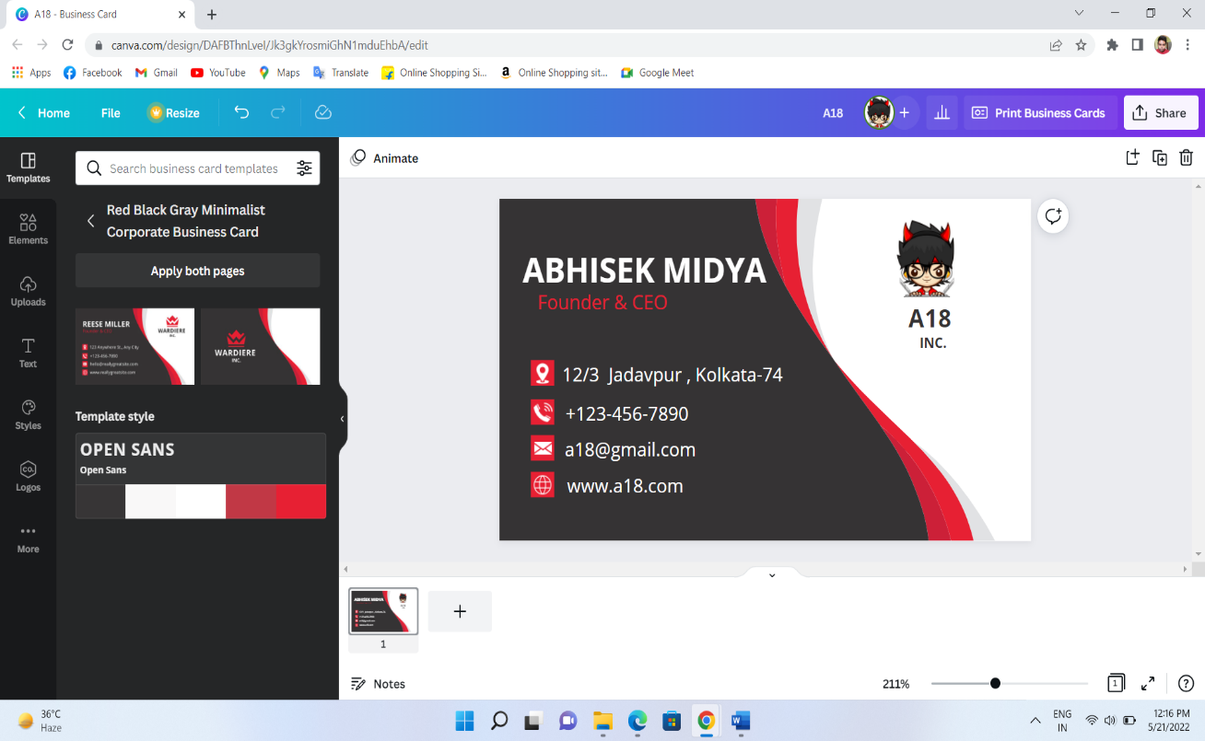

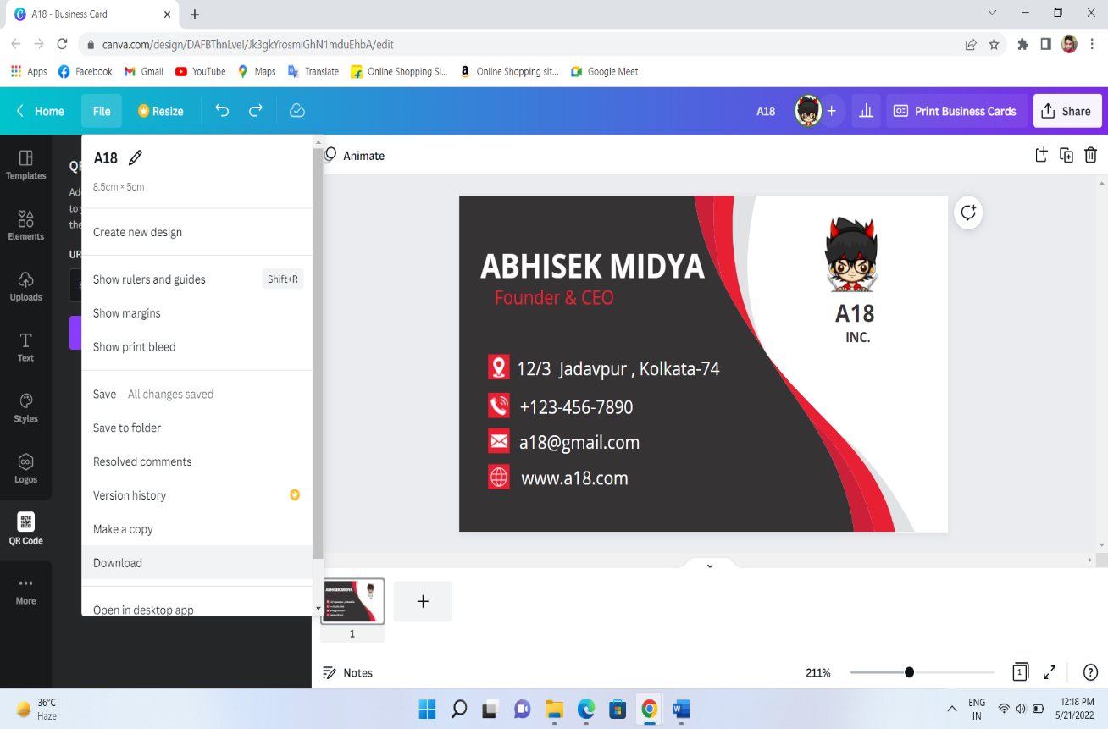

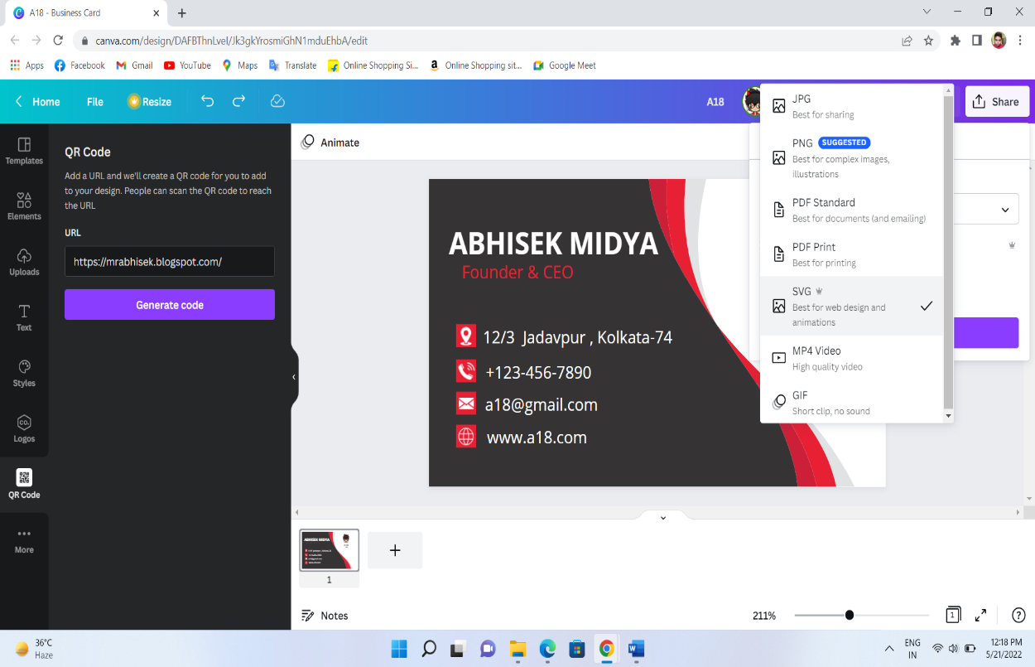

* **Output:**

